BFS with Queue & Node

Python.file:

Screenshot:
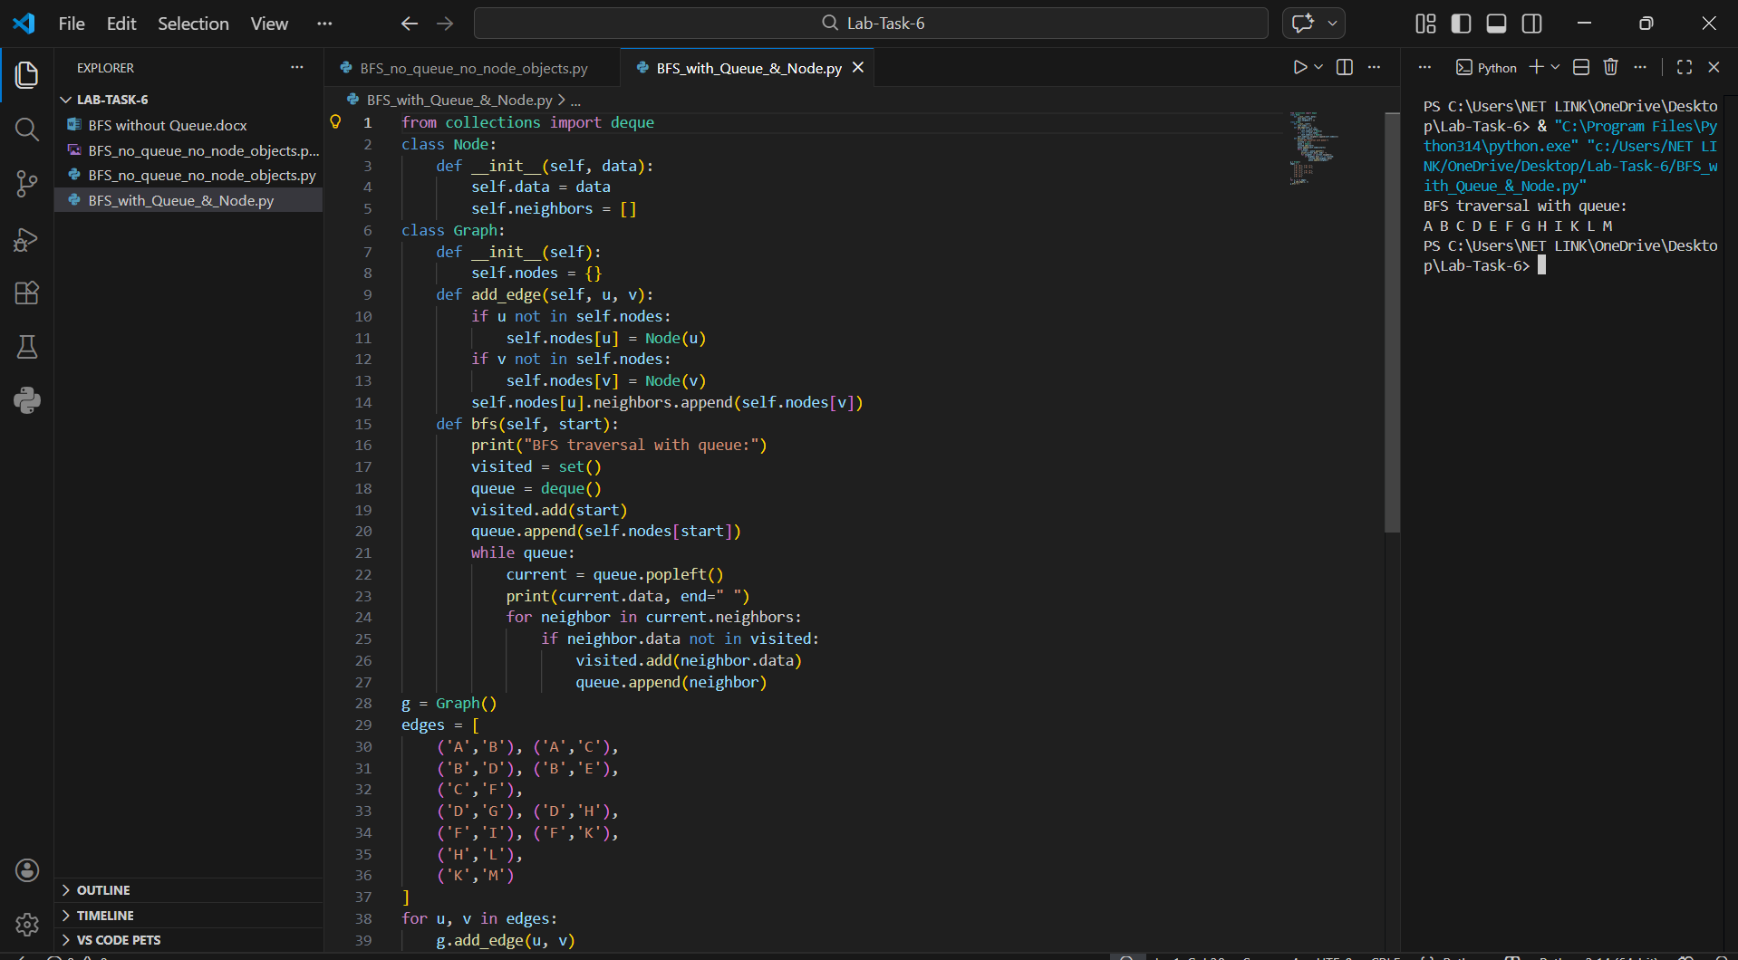

Details:
This Python program implements the Breadth First Search (BFS) traversal on a Graph using OOP.
It allows the user to:
• Create a graph
• Add edges between nodes
• Traverse the graph using BFS
• Display traversal output
• Exit after traversal
The program runs in the terminal.

Main Components:
• Class: Node
• Class: Graph
• Dictionary used to store nodes: self.nodes = {}
• Method to add edges: add_edge()
• Method to perform traversal: bfs()
• Queue used for BFS: collection.deque()
• Visited set to track visited nodes

How the Program Works:

1️. Start:
• The program creates an empty graph.
• An object of the Graph class is created.
• Edges are added to build the graph structure.
• bfs(“A”) method is called to start traversal.

2️. Add Edge:
• add_edge(u,v) method is used.
• If nodes do not exist → they are created using Node class.
• The edge is added to the adjacency list (neighbors list).
• The graph is directed (u → v).

3️. BFS Traversal:
• bfs(start) method is called.
• A visited set is created to track visited nodes.
• A queue (FIFO) is created using collection.deque().
• Start node is added to visited and queue.
Then the algorithm works as follows:
• Remove node from queue using popleft()
• Print the node
• Check its neighbours
• If neighbour not visited →
→ Mark as visited
→ Add to queue
• Repeat until queue becomes empty

